Sewer Report
Confidential and Proprietary
Jetters & Snakes Drain Cleaning Company
7435 North Figueroa St # 41222 Los Angeles 90041
818-471-9833 / 909-303-3189 / JettersnSnakes@Gmail.com
All Rights Reserved Copyright 2018 WWW.JettersnSnakes.com Page 1

3863 Yukon Street Los Angeles, California 91658
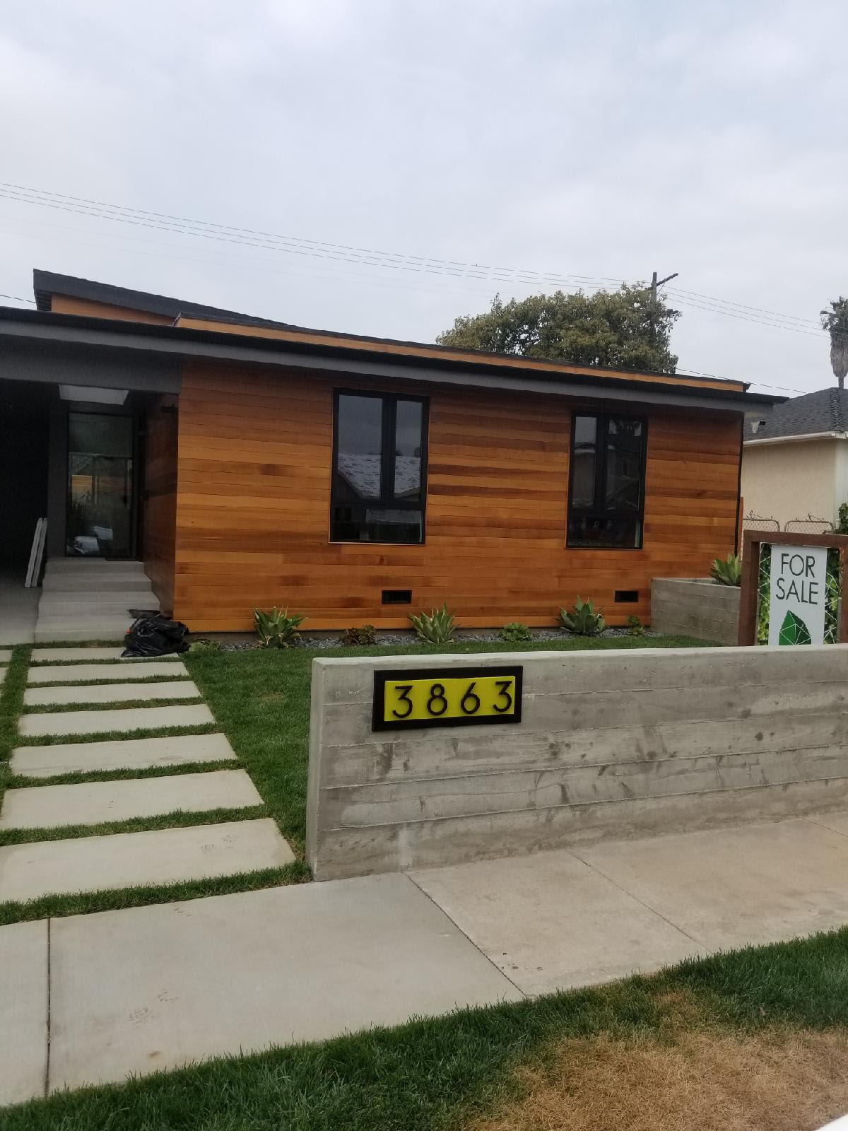

Confidential and Proprietary
Jetters & Snakes Drain Cleaning Company
7435 North Figueroa St # 41222 Los Angeles 90041
818-471-9833 / 909-303-3189 / JettersnSnakes@Gmail.com
All Rights Reserved Copyright 2018 WWW.JettersnSnakes.com Page 2

INTRODUCTION:

This is a video inspection of the interior of the main sewer line. This is the portion of the waste pipe system that carries the waste from the structure to the city sewer connection.
This report is based on a interior video inspection of this main sewer line only. Any other parts of the waste supply system are not included. The reports are not intended as a code inspection and/or list each flaw seen, nor detect each lateral present.
The goal of this sewer inspection is to report or identify some of the visible issues and put you in a better position to make an informed decision and is not intended to eliminate all risk associate with the home property purchase or selling . This report is a general guide and provides you with some objective information to help you make your own evaluation of the overall condition of the main sewer. It gives an overall picture of the condition of the interior of the main sewer line in the opinion of the technician at the time of the inspection.
Anywhere in the report that the inspector recommends further review, it is strongly recommended that this be done PRIOR TO THE END OF THE CONTINGENCY PERIOD. This report is not intended for use by anyone other than the client named herein. No other persons should rely upon the information in this report. Client agrees to indemnify, defend and hold inspector harmless from any third party claims arising out of client's unauthorized distribution of the inspection report.
By accepting this inspection report, you acknowledge that you have reviewed and are in agreement with all of the terms contained in the standard contract provided by the inspector who prepared this report.

MAIN SEWER LINE OBSERVATIONS
Main sewer lines are inspected only where they are accessible. This inspection report is based on a camera video of the main sewer line. Main sewer lines start, typically, two feet outside the footprint/ foundation line of the structure, is located underground and connects to the city sewer. This report does not include the buildings drain lines. Building drain lines are typically above ground and, for the purpose of this report, defined as drain lines that are located within the buildings footprint or foundation line.
This report is based on the inspector's education, opinion and observation of accessible existing
conditions at the time of this inspection.
While some plumbing observations may be code related, this inspection does not determine that the system complies with the jurisdictional codes.

Confidential and Proprietary
Jetters & Snakes Drain Cleaning Company
7435 North Figueroa St # 41222 Los Angeles 90041
818-471-9833 / 909-303-3189 / JettersnSnakes@Gmail.com
All Rights Reserved Copyright 2018 WWW.JettersnSnakes.com Page 3

INSPECTION CONDITIONS
CLIENT & SITE INFORMATION:

DATE OF INSPECTION: 4-30-16

TIME OF INSPECTION: 11am

CLIENT NAME: Mr. & Mrs. Williams

ADDRESS: 3863 Yukon Street

INSPECTOR: Jeffrey

HOW MANY PAGES:

CLIMATIC CONDITIONS: Overcast

TEMPERATURE: 65

BUILDING CHARACTERISTICS: Single Family Dwelling

UTILITY SERVICES: Water on, Gas off, Electric on

SEWER: 4inch Abs coming out to 6 Clay pipe

OTHER INFORMATION

OCCUPIED: No

CLIENT PRESENT: No

ENCLOSED:

Confidential and Proprietary
Jetters & Snakes Drain Cleaning Company
7435 North Figueroa St # 41222 Los Angeles 90041
818-471-9833 / 909-303-3189 / JettersnSnakes@Gmail.com
All Rights Reserved Copyright 2018 WWW.JettersnSnakes.com Page 4

INSPECTION REPORT:
Ran video camera through 3 inch cleanout on exterior wall , Saw little debris in sewer but still hydro jetted to main outside of house near crawl space
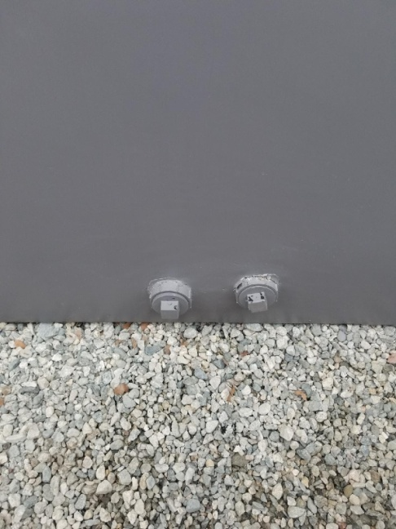

Confidential and Proprietary
Jetters & Snakes Drain Cleaning Company
7435 North Figueroa St # 41222 Los Angeles 90041
818-471-9833 / 909-303-3189 / JettersnSnakes@Gmail.com
All Rights Reserved Copyright 2018 WWW.JettersnSnakes.com Page 5

INSPECTION REPORT:

Ran video camera through 4 inch abs cleanout in the ground near front door, Saw debris in sewer (see picture 1, 2 and 3 on next page). Hydro jetted to main sewer to city later and ran camera again and found 2 cracks in pipe( see pictures 4 and 5 on next page)
First crack about 6 feet down the line from the cleanout and then another about 14 feet from the first crack
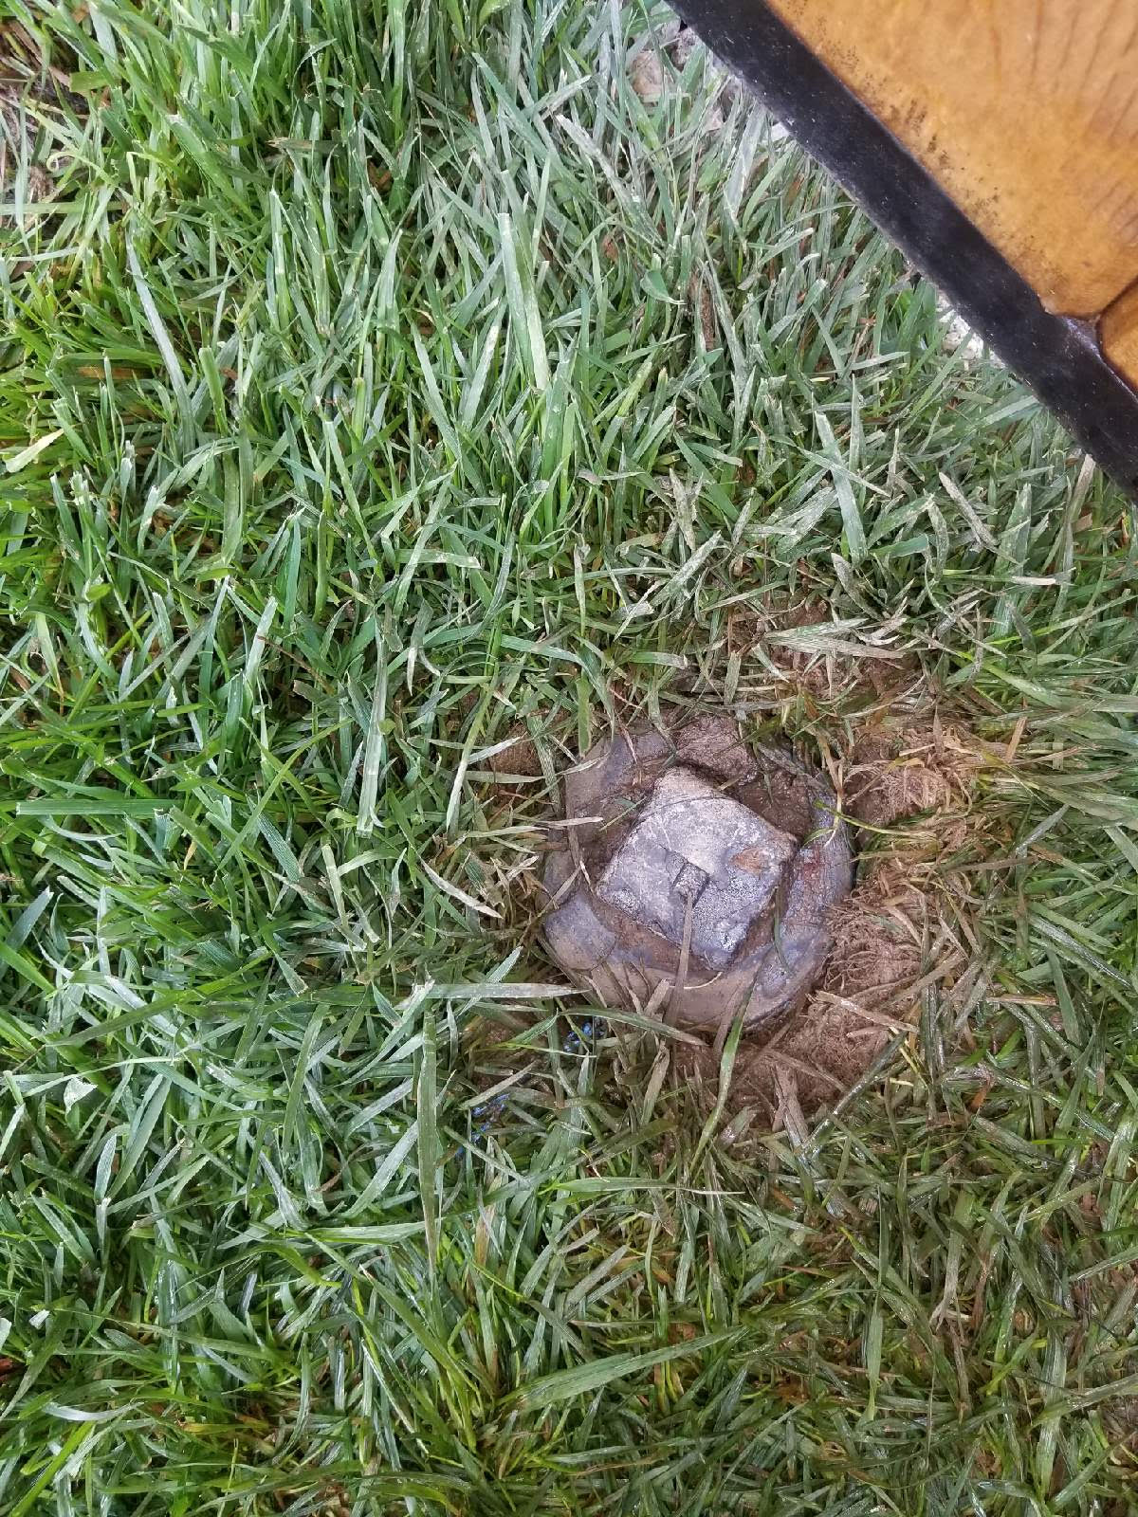

Confidential and Proprietary
Jetters & Snakes Drain Cleaning Company
7435 North Figueroa St # 41222 Los Angeles 90041
818-471-9833 / 909-303-3189 / JettersnSnakes@Gmail.com
All Rights Reserved Copyright 2018 WWW.JettersnSnakes.com Page 6

Pictures:
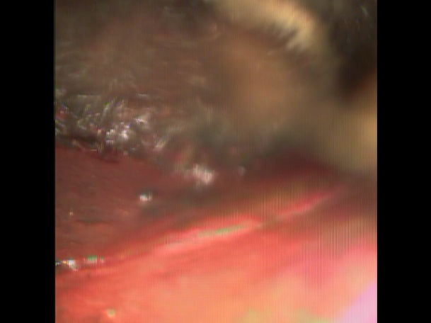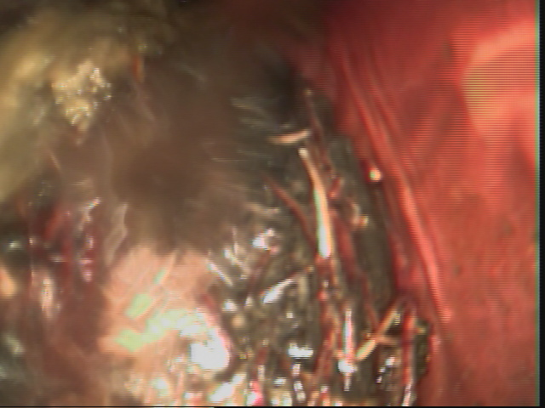
Picture 1 Picture 2
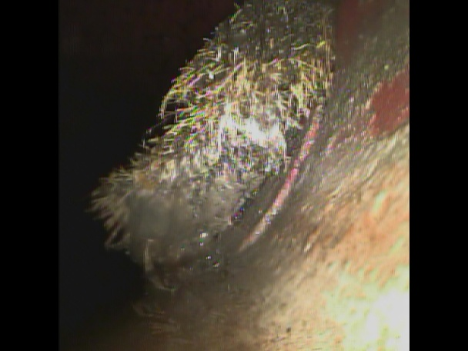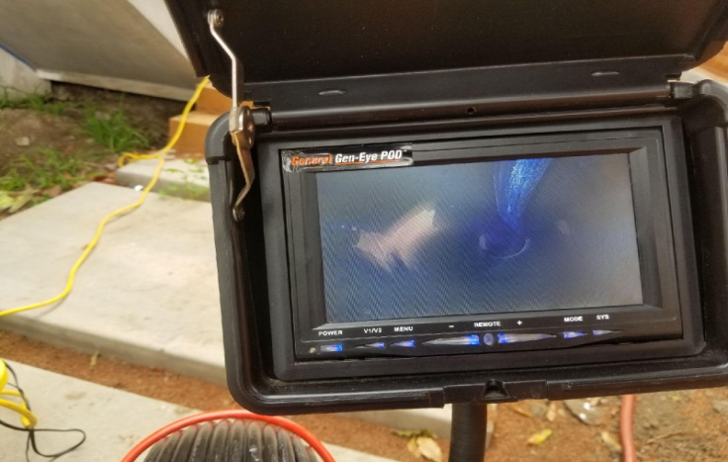
Picture 3 Picture 4
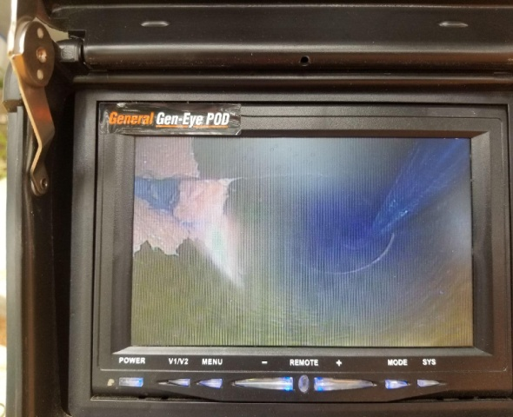
Picture 5

Confidential and Proprietary
Jetters & Snakes Drain Cleaning Company
7435 North Figueroa St # 41222 Los Angeles 90041
818-471-9833 / 909-303-3189 / JettersnSnakes@Gmail.com
All Rights Reserved Copyright 2018 WWW.JettersnSnakes.com Page 7

Recommendations:
Replace 4’ clay pipe from 4’ Abs cleanout about 20 feet downstream and hydrojet and video camera line again after excavation of sewer to remove dirt and debris that will occurred. Also have main line sewer jetted with high pressure water ( Hydro Jetter ) to remove debris off inner walls of pipe. It is also recommended that a sufficient 2 inch cleanout is installed at rear of home near kitchen to provide access to main line sewer. Estimated Costs for Repairs – $1500 to $3000 for sewer repairs
MAINTENANCE RECOMMENDATIONS :
Annual cleaning to help minimize future blockage or damage.

Confidential and Proprietary
Jetters & Snakes Drain Cleaning Company
7435 North Figueroa St # 41222 Los Angeles 90041
818-471-9833 / 909-303-3189 / JettersnSnakes@Gmail.com
All Rights Reserved Copyright 2018 WWW.JettersnSnakes.com Page 8

Customers Name: Mr. & Mrs. Williams
Customers Address: 3863 Yukon Street
Invoice #: 1134
Date of Invoice: 4-30-16
Job that was done: Hydro jetting main sewer
Warranty: 1 Year from Invoice Date
Authorized Warranty: Jeffrey Lippiatt
Warranty is only on the main sewer line from 4’inch cleanout on the right side of house near crawl space to the city lateral
All secondary drain line, Kitchen drain , Laundry drain line , All toilets , All lavatory sinks ,All shower and bathtubs ARE NOT UNDER ANY TYPE OF WARRANTY FROM JETTERS & SNAKES DRAIN CLEANING COMPANY

Confidential and Proprietary
Jetters & Snakes Drain Cleaning Company
7435 North Figueroa St # 41222 Los Angeles 90041
818-471-9833 / 909-303-3189 / JettersnSnakes@Gmail.com
All Rights Reserved Copyright 2018 WWW.JettersnSnakes.com Page 9

Limited Warranty for Hydro jetting Main Sewer Lines
Jetters & Snakes Will Give A Warranty On Main Sewer Drains After A Video Camera Is Put Into The Line To See How Bad The Drain Or Drains Are. This is included with our Service Depending How Bad The Drains Are This Could Be Amount Of Tree Roots, Separations, Dirt And Debris In The Line And If It Was Possible To Remove All The Debris In The Line, Our Service Tech Will Determined A Warranty And Will Let The Customer On The Final Invoice.
If there is a warranty and your Sewer backs up, we will come out at no cost to our customer.
THERE WILL NOT BE A WARRANTY IF THE FOLLOWING IS FOUND:
- MASSIVE AMOUNT OF MUD OR DIRT THAT CAN NOT BE REMOVED WITH REGULAR SEWER MACHINE EQUIPMENT ( THIS DOES NOT INCLUDED HYDRO JETTER MACHINE)
- DEBRIS , GREASE , FOOD ABUSE FROM USING GARBAGE DISPOSAL
- GROWTH OF TREE ROOTS THAY CAN NOT BE REMOVED WITH EQUIPMENT
- GRASS , LEAVES AND ANY TYPE OF FOLIAGE
- WOMEN PRODUCTS , TAMPONS , KOTEX , ANY FOREIGN OBJECTS
- CHILDRENS TOYS , SPONGES ANYTHING THAT ISNT SUPPOSE TO BE FLUSHED
If A Warranty Is Given, And A Service Tech Has To Return Due To Drains Not Working Or Clogged Up And Finds The Drain Or Drains Have Any Of The Listing Above In The Drains
THE WARRANTY WILL BE VOIDED!! AND A CHARGE TO REDO THE LINES WILL BE CHARGED, THIS IS DUE TO CUSTOMER NOT PROPERLY MAINTAINING THE DRAINS.

Confidential and Proprietary
Jetters & Snakes Drain Cleaning Company
7435 North Figueroa St # 41222 Los Angeles 90041
818-471-9833 / 909-303-3189 / JettersnSnakes@Gmail.com
All Rights Reserved Copyright 2018 WWW.JettersnSnakes.com Page10

